**Ch4-HSDProject**

**Homework:** Chapter 4 Heather Sweeney Design Projects (15 points) - Due ___ ___ __ Before Class

* Note: The Heather Sweeney (HSD) lessons, tutorials, and assignments use a simpler/older version than shown in the current textbook. The most significant difference is the identifier of the CONTACT entity.

**Figure 4-21(c): The Final Data Model for Heather Sweeney Designs**

Note: We are not using the INVOICE, LINE_ITEM, and PRODUCT tables.

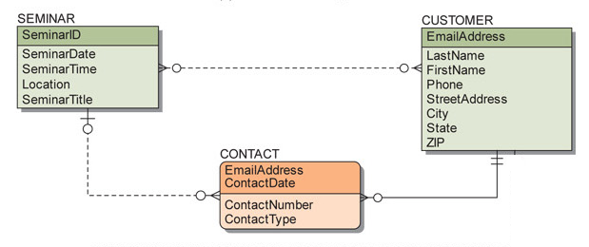

**Entity-Relationship Diagram:** (10 points) Suppose that Heather Sweeney wants to include records of her consulting services in her database. Extend the data model in Figure 4-21(c) to include CONSULTING_PROJECT and DAILY_PROJECT_HOURS entities.

* CONSULTING_PROJECT contains data about a particular project for one of Heather's customers:
  + ProjectID, ProjectName, Description, StartDate, EndDate, TotalHoursEstimate, TotalCostEstimate, TotalHoursActual, and TotalCostActual
* DAILY_PROJECT_HOURS contains data about the hours spent and a description of the work accomplished on a particular day for a particular project:
  + ProjectID, WorkDate, HoursWorked, and WorkDescription
* Use strong and/or weak entities as appropriate.
  + Do not use surrogate identifiers for potentially ID-dependent entities.
* Specify minimum and maximum cardinalities.
* Use the IE Crow's Foot E-R model for your E-R diagram.

**HSD Database:** (5 points) Create an Access database named HSD.accdb.

* Create the CUSTOMER, CONSULTING_PROJECT, and DAILY_PROJECT_HOURS tables.
* Create the primary and foreign keys in each table, and the relationships between the tables.
* Add at least three rows of data in each table.
* You may use either the Access GUI or SQL for any parts of the database.
* You will use your HSD database to write and run queries in future assignments.